SYSTEM ANALYSIS AND

DESIGN

UNIT – 2

**Introduction of Software Engineering and Software Development Models**

Shree M. & N. Virani Science College (Autonomous)

ATMIYA Group of Institutions, Yogidham Gurukul, Rajkot.

Priyank Doshi

Asst. Professor (MCA, MSc.(Math) )



**INTRODUCTION TO SOFTWARE**

**ENGINEERING**

.

The technology encompasses a process, a set of methods –

frame work, and an array of tools that we call software

engineering.

.

Computer software is the product that software engineers

design and build by applying a process (software engineering

approach) that leads to a high – quality result that meets the

needs of the people who will use the software.

.

Software is both a product and a Tool for producing a product.

Shree M. & N. Virani Science College (Autonomous)

ATMIYA Group of Institutions, Yogidham Gurukul, Rajkot.

Priyank Doshi

Asst. Professor (MCA, MSc.(Math) )



**Products (Software)**

.

It delivers the computing potential embodied by computer

hardware or a network of computers that are accessible by local

hardware. Whether it resides within a cellular phone or operates

inside a mainframe computer, software is an information

transformer – producing, managing, acquiring, modifying,

displaying, or transmitting information that can be as simple as a

single bit or as complex as a multimedia presentation.

Shree M. & N. Virani Science College (Autonomous)

ATMIYA Group of Institutions, Yogidham Gurukul, Rajkot.

Priyank Doshi

Asst. Professor (MCA, MSc.(Math) )



**Tool for delivering a Product**

.

.

.

We develop our product (Software) using another software which includes

operating system, languages, packages, database, computer aided

software development tools. We also use network and network software to

accomplish developing task of new software.

To develop software Project Management required. Which includes

**planning, monitoring and controlling** of the **people, process, and**

**events** in the software industry as software evolves from a preliminary

concept to an operational implementation.

Everyone “manages” to some extent but the scope of management

activities varies with the person doing it.

Shree M. & N. Virani Science College (Autonomous)

ATMIYA Group of Institutions, Yogidham Gurukul, Rajkot.

Priyank Doshi

Asst. Professor (MCA, MSc.(Math) )



.

.

.

**Person**

**---**

**Manages**

Software Engineer ---

day to day activities

work of team of software

Project Manager

engineers

---

---

.

Senior manager

Coordinates the interface

between the business and the

software professionals

Shree M. & N. Virani Science College (Autonomous)

ATMIYA Group of Institutions, Yogidham Gurukul, Rajkot.

Priyank Doshi

Asst. Professor (MCA, MSc.(Math) )



Software Engineering:- A layered Technology

Shree M. & N. Virani Science College (Autonomous)

Priyank Doshi

Asst. Professor (MCA, MSc.(Math) )

ATMIYA Group of Institutions, Yogidham Gurukul, Rajkot.

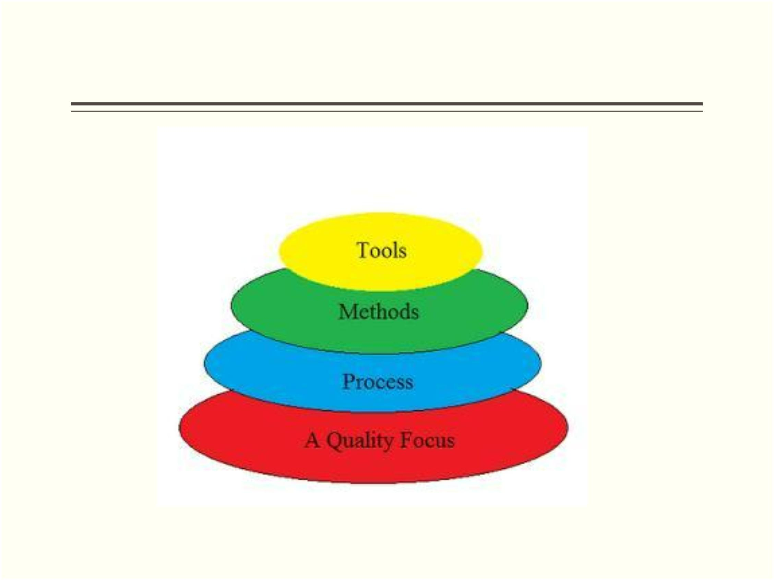

Process

.

The foundation for software engineering is the *process* layer.

Software engineering process is the glue that holds the

technology layers together and enables rational and timely

development of computer software.

.

The key process areas form the basis for management control of

software projects and establish the context in which technical

methods are applied, work products (models, documents, data,

reports, forms, etc.) are produced, milestones are established,

quality is ensured, and change is properly managed.

Shree M. & N. Virani Science College (Autonomous)

ATMIYA Group of Institutions, Yogidham Gurukul, Rajkot.

Priyank Doshi

Asst. Professor (MCA, MSc.(Math) )



Method

.

Software engineering *methods* provide the technical how-to's for

building software. Methods encompass a broad array of tasks

that include requirements analysis, design, program

construction, testing, and support. Software engineering

methods rely on a set of basic principles that govern each area

of the technology and include modeling activities and other

descriptive techniques.

Shree M. & N. Virani Science College (Autonomous)

ATMIYA Group of Institutions, Yogidham Gurukul, Rajkot.

Priyank Doshi

Asst. Professor (MCA, MSc.(Math) )



Tools

.

Software engineering *tools* provide automated or semi-automated

support for the process and the methods. When tools are integrated

so that information created by one tool can be used by another, a

system for the support of software development, called *computer-*

*aided software engineering,* is established. CASE combines

software, hardware, and a software engineering database (a

repository containing important information about analysis, design,

program construction, and testing) to create a software engineering

environment analogous to CAD/CAE (computer-aided

design/engineering) for hardware.

Shree M. & N. Virani Science College (Autonomous)

ATMIYA Group of Institutions, Yogidham Gurukul, Rajkot.

Priyank Doshi

Asst. Professor (MCA, MSc.(Math) )



Quality

.

Total quality management and similar philosophies foster a

continuous process improvement culture, and this culture

ultimately leads to the development of increasingly more mature

approaches to software engineering. The bedrock that supports

software engineering is a quality focus.

Shree M. & N. Virani Science College (Autonomous)

ATMIYA Group of Institutions, Yogidham Gurukul, Rajkot.

Priyank Doshi

Asst. Professor (MCA, MSc.(Math) )

